RPS Scotland response to Single Medication Record survey

Link to survey: https://forms.office.com/r/VTy2Ra8YB6
Questions 1-5 are demographic

Questions 6 and 7 are prioritising benefits, ranked orders below
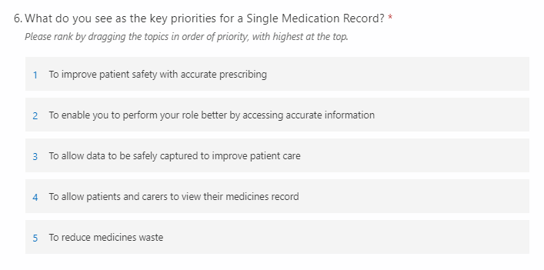

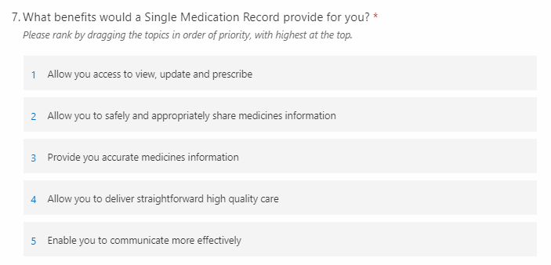

Questions 8-10 are free text
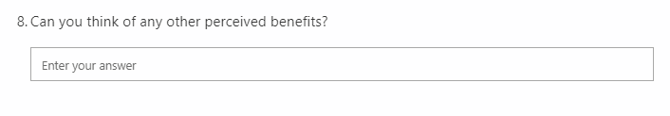One of the biggest risks in health and social care is poor information and communication. It is because of this that RPS Scotland has been campaigning for years for read-write access to shared patient records for pharmacists.
We agree with all the benefits listed in questions 6 and 7. Additional benefits are:
- Enabling all professionals to see a complete picture of a patient’s medicines, which is currently hidden by separate records in separate locations
- Improving the efficiency of working, by providing timely access to medicines information and reducing time professionals spend on phone calls, emails and letters to both find out and provide medicines information
- Support multi-professional working across care interfaces
- Improves medicines safety, for example by creating a reliable system for accurate documentation of allergies and adverse drug reactions
- Avoiding the need for patients to be asked the same questions multiple times by different professionals
- Supporting person-centred care and shared decision making by enabling patients to enter information about medicines into a single record, such as recording medicines they purchase, side effects they are experiencing and questions they would like to ask in medication reviews

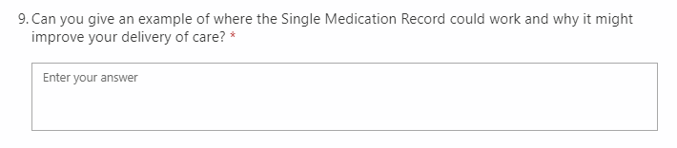
RPS Scotland wants to see one universal patient record, with every profession writing into this shared record from their own clinical system and every profession reading this same shared record from their own clinical system. Views could be tailored according to what is appropriate for each professional group.
A specific example of how this would improve delivery of care is in transforming medicines reconciliation. This is the process of collecting information to get a complete drug history and accurate list of patients’ current medicines from which a new ‘active’ list of medication can be compiled based on the clinical situation of the patient. This involves manually accessing multiple sources of information to ensure a complete list is obtained and documenting this information. Medicines reconciliation occurs at every care interface, for example hospital staff, usually medics or pharmacists, complete medicines reconciliation when a patient is admitted to hospital and general practice staff complete it on receipt of a hospital discharge letter. It is a process that takes significant time and there is always a risk that a patient’s medicines will not be identified correctly, that information will be documented incorrectly and that changes to medicines will not be communicated.
Having a single medication record would be transformational because it would eliminate the need for the technical reconciliation process for medicines. Instead, the patient’s medicines record would be updated at the point of care and this record would be accessible to the next professional providing care for that patient, even if that was just 5 minutes after the previous professional contact.
This would release a significant amount of professional capacity which could instead be spent on clinical activities. This is particularly important at a time when the NHS is so stretched because of the Covid-19 pandemic. Clinical activities could include talking to the patient about the changes to their medicines following the care transition. This would help identify and address any problems, therefore optimising medicines use.
Replacing medicines reconciliation with a single medication record would also improve safety in terms of reducing the risk of transcription errors (documenting medicines) and the risk of changes to medicines not being communicated.

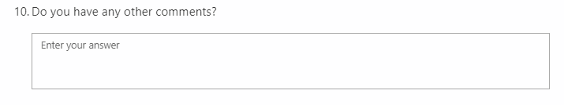
As the professional leadership body for pharmacists in all sectors across Scotland, RPS Scotland is keen to work with the Scottish Government’s Closing the Loop team to support the introduction of a Single Medication Record.
In order to make a Single Medication Record successful, the following should be considered:
- Data modelling for the medication record:
  - Must be interoperable with clinical systems at both prescribing and dispensing ends of the Primary Care continuum, and interoperate/integrated with secondary care system. Ideally, data should be viewed from a professional’s native system (for example, community pharmacy patient medication record, GP clinical system, hospital HEPMA system) and not have to be looked at in another system (portal?) which may prevent full interaction.
  - In terms of coding: must be dm+d native, which is especially important as the work to move from Read to SNOMED CT is about to start. This will be a problem for secondary care systems that are not wholly dm+d compliant, and is also an issue for specials in community pharmacy systems.
- Within pharmacies, it is likely and appropriate for both pharmacists and pharmacy technicians to access the record.
- Clarification is needed around how authentication of different clinical staff accessing the record is done:
  - If using Office 365 identity management, this will work for pharmacists in secondary care who have )365 identify. The situation in primary care is different: each pharmacist in primary care (including community pharmacy) would require an individual O365 identity which is not the case at the moment. There will be a cost implication of this for NHS Boards/Scottish Government which must be addressed.
  - If using other methods, then all individuals across Scotland who should have access to the record would require to have additional accounts for this.
- Levels of access must be clarified (i.e. read-only and read/write access) and assurances are vital that pharmacists have the correct level of access based on their roles.
- Support functions must be available to help individuals get it right, first time. This might include a service management wrapper and a single point of contact (helpdesk) to deal with errors/data issues/access problems/etc.
- Compatibility issues and firewalling issues must be addressed for large multiple community pharmacies which have these within their own IT networks.
- Clinical content currently missing in the Emergency Care Summary specifically relating to medicines must be assessed and addressed, such as including detailed information about allergy to medicines and vaccination status.
- Specific flagging should be included to identify patients with additional requirements such as monitored dosage systems and medication administration records to ensure care is streamlined for patients as they cross sectors. Missing this detail often leads to delays to discharge or problems once home.
- In the future, ALL medication, including, for example, homecare medication and ATMP’s should ideally be included withing the single medication record. However, we appreciate this will be an addition and the priority is to get the record established initially.

